MADUR KATHI: AN IMPORTANT ECONOMIC NON-FOOD CROP OF WEST BENGAL

Mr. Gour Hari Mondal, Assistant Professor, Departmment of English, Sabang Sajanikanta Mahavidyalaya, Vidyasagar University, Paschim Medinipur , , , West Bengal.

Abstract
Improved agro-techniques are needed for higher returns in mat handicraft products. As the mat-sedge is perennial in nature and grows round the year, annually three cuttings are taken consecutively at the end of kharif, winter, and summer season. From this raw material, mats are generally made with the help of a few wooden pegs, poles, and threads at home. Even an elderly man or woman (aged family members of a farmer's family) in rural areas can earn a net income of about 60 to 80 rupees per day. The ever growing population poses a number of problems and the major thrust falls on the agricultural sector. Presently, agriculture is facing under-employment. Cultivation of mat-sedge crop and its value-added products and production of mat-reed of different quality can play a vital economic role. In West Bengal, India about 100,000 farm families are associated and solely or partly dependent on mat-sedge cultivation for their secured livelihoods.

Key Words: Madur, Madur-kathi, Sitalpati, Agroclimatic conditions, Mat-sedge.

Introduction

India is traditionally a country of artistic crafts and handicrafts. For a long period of time these craft works in India were found to be concentrated in specific geographical locations based upon a system of occupational specialisation which in small segments of community created a special art folk. Mat weavers, specialised in weaving of varieties of mats constitute a section of such Indian art folk. The history of mat weaving in India dates back to the Indus Valley Civilisation. Its socio-cultural relevance can be heard in ancient literature. Records of the Medieval Period provide the first information of mat weaving in West Bengal. Further, authorities like: Hunter (1876), O’Melley (1911), Porter (1933), Mitra (1951) and others have highlighted the socio-economic aspects of mat industry during the 19th and 20th centuries. Mats in India are of different kinds and are produced in different parts of the country.

However, the finer variety of mats, especially manufactured from madur grass (Cyperus tegetum) is concentrated in south-eastern part of the district of Midnapore. Weaving of mats has developed itself as an important cottage industry in the district, offering employment to rural masses, particularly the women and children in villages. The industry thus helps them to earn subsistence income. The production of mats, if taken together, accounts for Rs 6 to 7 crores in the aggregate annual income of the district. In spite of such positive aspects, no systematic and scientific study has yet been attempted on the industry. Endeavour has, therefore, been made for a systematic study into the different aspects of mat industry in the district of Midnapore. An independent primary survey has been conducted with a view to study the general features of the industry, its organisational and capital structure, aspects of employment and output, marketing network and also the cost-price structure. Attempts have also been made to provide some recommendations in the form of suggestions which can help the industry to overcome its present problems and finally to attain the standard level of efficiency.
Methodology and Sample Design

Essentially, the study is explorative in nature and based on primary data collected through field investigation. The technique of ‘Multi-Stage Random Sampling’ has been adopted for the purpose of sample selection. Initially from the 220 mat producing villages of police station Sabang, 35 have been selected as sample villages after two stage stratifications. Thereafter, from each selected single and double mat producing sample village, 10 per cent of the mat weaving households subject to a minimum of 5, have been selected as sample units on random basis. However, for masland producing units, complete enumeration has been made. Thus, altogether a total number of 303 sample mat weaving units have been selected for intensive study. Data have been collected through personal contact from sample units. Analysis of data has been made with the help of manually operated calculators.

- Salient Features of Mat Industry

The students of Sabang Sajanikanta Mahavidyalaya came to Sarta in 2022 for a survey where they met with a great person name Pushpa Rani Jana. In 1989 she got the Tamralipta award from the hand of our P.M. and also won the Rastriya award in 2001. Information collected from field survey reveals that mat industry in the district of Midnapore typically represents the nature of a household industry. Production by the units is run in a household environment with the active participation of household members. As such, the units in general are tiny in size. In terms of number of looms possessed, it is seen that nearly 86 per cent of the sample units are having one loom, while 14 per cent of the units operate with double looms. In terms of the number of artisans employed and annual value of output also, the mat weaving units by and large are smaller in size.
Mat production is an organized industry and the mats are woven mainly by the weavers of the Mahishya caste, and predominantly by women in the southern part of the district of Paschim Medinipur, which covers the whole coastal area of West Bengal, west of the river ‘Ganga’. Cultivation of mat-sedge and its valuable products can play an important economic role in rural areas of West Bengal, India. Mat-sedge provides a gainful employment opportunity to the resource-poor farming community for their secured livelihoods. A preliminary survey and contact with the farmers at Sabong and Pingla blocks in Paschim Medinipur district of West Bengal indicated that it is widely cultivated mostly as a monocrop with poor management practices by the poor and marginal farmers, resulting in low returns.

The craft of ‘Madur’ weaving is practiced in the residence-cum-workshops of artisans’ households with the help of family members. This rural handicraft provides employment to a large number of artisans, mostly in the Paschim Medinipur district. With the partition of India and the formation of Bangladesh, many Bangladeshi mat weavers migrated to West Bengal and started popularizing the craft. They are skilled at weaving the most popular Madur mats.

Historicity of Mat-sedge and ‘Madur’

‘Madur’ mat weaving is an old cottage industry in India, with references dating back to the Atharvaveda (references to kapisu or mats/madur from grass). References of mats found in the sacred scriptures of ancient Sanskrit literature indicate that mats are of considerable antiquity. Madur is one of the most popular mats among the numerous varieties of mats made in West Bengal. The mat is woven on a simple bamboo frame-loom. The warp is cotton thread and the weft is a thin soft reed called ‘madur kathi’. References have been made in the Satapatha Brahmana, Mahabharata, and Atharvaveda. The origin of the craft in West Bengal dates back to the Muslim period, when ‘masland’ mats of superﬁne variety with silk yarn as weft were produced under royal patronage. During this period, the craft had ﬂourished in Midnapore district (now Paschim Medinipur). Mats would be collected as revenue of the jaigirdari system. Nawab Alibardi Khan issued a charter to the jaigirdars in this regard and as a result, it was obligatory to supply ‘masland’ mats for use in the collectorate. They had formed permanent markets for mats in Midnapore. Kasijora and Narajol were the two most important centers of ‘masland’ mat weaving during this period. Mats of ordinary variety were also produced. Government ofﬁcials in the British period found that a large number of ‘masland’ mats were being manufactured in Midnapore, some of which were being sold at more than 100 rupees per mat. It is reported that 448,300 mats were manufactured during 1907–08.

- Types of Madur Mats:

Midnapore craftsmen design three types of Madur mats. The three types of mats are woven as ekh-rokha, do-rokha, and masland. Do-rokha is thicker than the ekh-rokha and is more suitable and comfortable when compared to ekh-rokha. The masland mat is very ﬁne textured and made of carefully selected reeds with beautiful geometric designs woven on it. These designs are self in colour but sometimes they are painted in magenta shade.

Species of Mat-sedge:

Mat-sedge, belonging to the family Cyperaceae, is a glabrous robust plant with culms of 1.5 to 2 m height arising from a creeping woody rhizome. There are several species under the genus Cyperus and these are mostly habitants in swampy, marshy land predominant in tropical to subtropical environmental conditions (CSIR, 1988). ‘Madur’ mat weaving is an old cottage industry in India, with references dating back to the Atharvaveda. Asian Agri-History Vol. 18, No. 2, 2014 147

Agroclimatic conditions and distribution of Mat-sedge:

Mat-sedge can thrive in a wide range of agroclimatic conditions and occurs in marshy situations especially in eastern and southern parts of India (Sarkar and Samanta, 1987). The plant is capable of tolerating extremities such as prolonged submergence in water and extended drought conditions. Sometimes swampy and marshy lands are used to cultivate non-food crops like mat- sedges. Watt (1889) refers to mats (commercially known as Calcutta mats) chieﬂy made from the inﬂorescence axis (culms) of C. tegetum, which is abundantly found in India in marshy areas. In low-lying areas in the eastern region, the productivity of rice is not high and utilization of land by growing mat-sedges for mat-making provides an alternative use of such marshy areas, resulting in more proﬁt and employment to the rural people. Introduction of mat-sedge cultivation on such poor type of lands would go a long way in achieving economic well-being of the farmers. Besides India, mat-sedge is also grown in Sri Lanka, Bangladesh, Nepal, China, Japan, Thailand, Malaysia, Java, and Sumatra.

Popular mat-sedge growing areas of West Bengal

Mat-sedge is mainly produced in Paschim Medinipur district (Sabong, Pingla, and Narayangarh blocks) and some areas in North 24 Parganas district (Habra, Nagar Ukhra, Gaighta, etc.) of West Bengal. In rural areas of Paschim Medinipur district, particularly Sabang block area, the Madur mat has gained wide popularity and even conferred with the President’s Award for its quality and artistic work. Sabang block is a very popular mat-sedge growing area under old alluvial zone of West Bengal. This zone comprises ﬂat alluvial plains intersecting with the main river system (Rupnarayan, Ajoy, Damodar, Kangsabati, Keleghai, Haldi, etc.) and its tributaries, canals, and low-lying areas subjected to frequent waterlogging and ﬂoods, making them swampy and almost non-cultivable during the peak kharif season. Cultivation of mat-sedge is remunerative in these areas with least investment in contrast to the cultivation of other crops like paddy, wheat, etc.

Madur kathi: an Economic Non-food Crop

Mat-sedge crop grows round the year. Mat-sedge crop is grown in all three seasons, viz., kharif season (June to end of September) and subsequent winter season (October to end of January) as well as summer season (February to end of May) (Jana and Puste, 2012). After full establishment of the crop in the ﬁeld, it may be possible to take three cuttings for economic return. Annually three cuttings are taken – ﬁrst cutting in the end of September (kharif), second in the end of January (winter), and the third cutting in the end of May (summer). The crop of kharif season accumulates higher dry matter yield of mat-stick as compared to the regeneration crop raised during winter and summer seasons. Mat-sedge crop during kharif season has taller plants, greater number of tillers m-2, more total green area index, and higher total dry matter production as compared to the crop grown during winter and summer. Lower values of almost all the parameters are observed in the regeneration crop during winter. This may be due to prevalence of cool temperature in winter months. The ratoon (regeneration) mat-sedge crop also succeeds for 5 to 6 years with successive returns and even it may continue to produce economically for 10 to 15 years under better management practices.
- Quality Characteristics

The yield attributing characters are important and are associated with the growth and vigour of the crop. Plant height and number of tillers m-2 produced from rhizomes inﬂuence the quality of mat-sedges. In addition, plant height is more important since it determines the original width of a hand-made mat, as the market price of the hand-made mat varies according to its width.

Medicinal value

The rhizomes are used as a tonic and stimulating medicine. Rhizomes are also used medicinally as diaphoretic, astringent, and diuretic. In native practice, rhizomes are held in great esteem as a cure scraped and pounded with green ginger, and in this form mixed with honey, they are given in cases of dysentery in doses of about a scruple. Rhizomes are extensively used as an aromatic adjunct to numerous compound medicines (Puste, 2004).

Dye
Rhizomes are in certain dye preparations to impart a perfume to the fabric and also for fragrance in hair lotions.
Oil
The rounded rhizomes yield an essential oil, which the natives of upper India use to
Perfume their clothes. In Bengal, the rhizomes of Cyperus scariosus are more largely used in perfumery, this species being more plentiful – in fact it is a troublesome weed.

Fodder
Some of the species of Cyperus are well-eaten by cows and occasionally by buffaloes but most of them are not fond of it.

Utility

In hot humid climate like India, Madur mats are very comfortable when spread over the hot, cold, or damp earthen or cemented ﬂoor, or even on cotton beddings, as they are bad conductors of heat. These are also easily accessible to the common people because they are comparatively cheaper and affordable even by the poor. A single mat lasts for about 3–4 years. Nowadays decorative and colourful mats are available in the market and are used in many religious and ritual functions.

Socioeconomic Importance

The mats are generally used for sitting as well as bedding purposes. In hot climate, the mats are very comfortable because of their non-conducting property and ability to absorb sweat. A common mat generally costs 50 to 80 rupees while a designed and embroidered mat costs 300 to 2000 rupees. The mats from Paschim Medinipur and North 24 Parganas districts are being exported to other countries. The proﬁt under good management conditions may be much higher than the proﬁt a farmer can get by growing two crops of rice per annum. Growing of raw materials including processing, drying, and bundling of harvested culms is very labour intensive. The split and dried sticks are either immediately used for making mats or kept for use in the off season, when there are no other farming operations. Mat making is very easy. From the raw material, mats are generally made with the help of a few wooden pegs, poles, and threads at home. Even an aged member of either sex of a farmer’s family in rural areas can earn a net income of about 60 to 80 rupees per day (Puste, 2004).
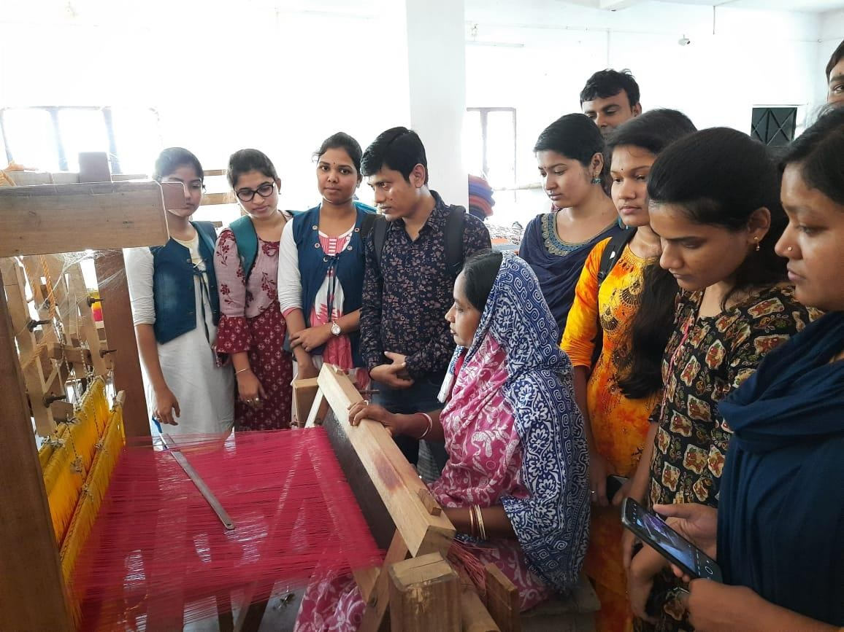

With students and Madur Artist in a Survey

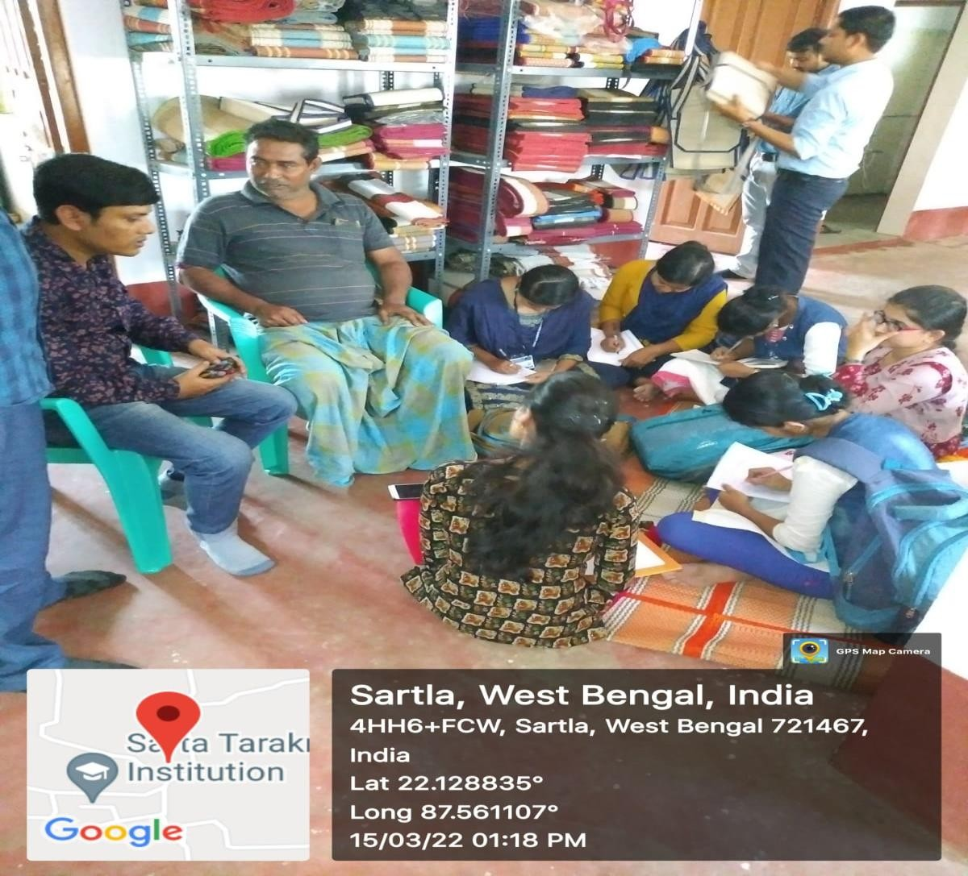

Taking interview of an Madur –Artist

- Value-added products from mat-sedge

Several valuable decorative products (>50 types, viz., different types of window screen, bags for men and women, mobile and ﬁle covers, hats, water-carrying bags, purse, shoes, pen stand, ﬂower vase, etc.) other than mattresses are being made. These are marketed in different parts of the country and also exported to other countries. Some NGOs and even some individuals are solely engaged for the purpose through self-helf groups. Production of these items is an alternative good source of economic return, which may help to improve the livelihood of farmers, particularly those who are inextricably linked with this ecosystem. Mat production is an organized industry and the mats are woven mainly by the weavers of the Mahishya caste in the southern part of the district of Paschim Medinipur, which covers the whole coastal area of West Bengal, west of the river ‘Ganga’. The craft of ‘Madur’ weaving is practiced in the residence-cum-workshops of artisans’ households with the help of family members. With the partition of India and the formation of Bangladesh, many Bangladeshi mat- weavers migrated to West Bengal and started popularizing the craft. They are skilled at weaving the most popular Madur mats.

Mat-sedge crop grown round the year

Mat-sedge crop is grown in all three seasons, viz., kharif season (June to end of September) and subsequent winter season (October to end of January) as well as summer season (February to end of May) (Jana and Puste, 2012). After full establishment of the crop in the field, it may be possible to take three cuttings for economic return. Annually three cuttings are taken – first cutting in the end of September (kharif), second in the end of January (winter), and the third cutting in the end of May (summer). The crop of kharif season accumulates higher dry matter yield of mat-stick as compared to the regeneration crop raised during winter and summer seasons. Mat sedge crop during kharif season has taller plants, greater number of tillers m-2, more total green area index, and higher total dry matter production as compared to the crop grown during winter and summer. Lower values of almost all the parameters are observed in the regeneration crop during winter. This may be due to prevalence of cool temperature in winter months. The ratoon (regeneration) mat-sedge crop also succeeds for 5 to 6 years with successive returns and even it may continue to produce economically for 10 to 15 years under better management practices.

- Types of Madur mats

Midnapore craftsmen design three types of Madur mats. The three types of mats are woven as ekhrokha, do-rokha, and masland. The Ekhrokha Madur is woven using a single reed Madur kathi weft and requires the least amount of skill. The Dorokha which employs a double reed waft requires good skill. It is thicker and more comfortable to sit on than the simple Ekhrokha madur. The masland mat is very fine textured and made of carefully selected reeds with beautiful geometric designs woven on it. These designs are self in colour but sometimes they are painted in magenta shade.

Processing of harvested culms of mat-sedge:

The mats are generally used for sitting as well as bedding purposes. In hot climate, the mats are very comfortable because of their non-conducting property and ability to absorb sweat. A common mat generally costs Rs 80 to Rs 100 while a designed and embroidered mat costs Rs 300 to 2000. The profit under good management conditions may be much higher than the profit a farmer can get by grow in two crops of rice per annum. Growing of raw materials including processing, drying, and bundling of harvested culms is very labour intensive. The split and dried sticks are either immediately used for making mats or kept for use in the off season, when there are no other farming operations. Mat making is very easy. From the raw material, mats are generally made with the help of a few wooden pegs, poles, and threads at home. Even an aged member of either sex of a farmer’s family in rural areas can earn a net income of about Rs100 to Rs150 per day.

Mataranchi

Masland or Mataranchi is an exclusive & expensive high ranged handmade variety of Madur made with intricate artistic skills woven by artisans of Sabang & Ramnagar. The time taken to make a Mataranchi varies from 2 weeks to about 3 months depending on factors like the fineness of the sticks, the number of warp threads per inch and the intricacy of the design.

Processing of harvested culms of Mat-sedge

S1: A special knife and technique used for splitting the mat-stick S2: Women engaged in bundling of split mat-sticks
S3: Different grades of split mat-stick bundles according to height

S4: Mats are generally made with the help of a few wooden pegs, poles, and threads S5: Cutting the mat sticks.

Suggestions

Government should give attention in upgradation and modernization of loom, equipments and infrastructural development for the betterment of the handloom mat weaving industry. In case of handloom, first of all, there is need to create awareness about the features and advantages of handloom mat products. Effective publicity through appropriate media mix should be done. Print and electronic media can be used in right proportion. A regular buyer- seller meet is required so that the weavers get a platform to market their products.
To bring superior quality in handloom products the pre and post loom process development should take place. Innovative and faster weaving processes and techniques to increase efficiency of weavers as well as loom will make handloom more competitive and profitable. Training to enhance the skills of mat weavers in manufacturing and marketing aspects in changing business environment. Effective implementation of various policies and programs could be successful when there would be proper integration, cooperation and coordination from the government. Skill and design development exercises can be conducted for the mat weavers which will help them to understand and develop new product range as well as improve their design sensibility.

Song at the time of Mat-Weaving
Mat-artists have sung very little types of folk songs during their work with mat. When we deeply study about the song we got some song references which is given below. In the Madur Festival they also used to sing folk songs.
Title of Song: Goalini goalini hatiya aaiso dhire Recorded on date: 24.04.2015
Language of recording: Assamese (Goalparia)
Location of recording (Address): Futkibari, Dhubri (Sabang)

Lyrics of song | Meaning
Goalini goalini hatiya aaiso dhire  O’ tok rojar beta kanaihya re O’ tok kenaba dakaise  O’ tor gaoer manjon dekhiya re O’ tok kenaba dakaise  Aare hemati-bitiri aro dhan phelailong jomine  Aare roibar nong aai mui roibar nong Mui jaim kanaihyar sathe re  Aare chawal rojai diche aro pan rakhichong jatone  Aare roibar nong aai mui roibar nong  Mui jaim kanaihyar sathe re  Oki bhala bhala re bhalo khopati goalini bara  bane re | We the women love to woven mat so oh night please come slowly  Son of king – Krishna (kanaihya) has called you,  but don’t know why  To see the cleanness of the village, Krishna (kanaihya) has called you, but don’t know why  We have broadcasted paddy seed in the field I will not stop ,I will not stop today  I will go along with Krishna  we use the mat for Krishna’s sleep, betel leave & nut has  been safely kept  I will not stop, I will not stop today I will go along with Krishna  Its so good that the mat woven woman wear
Goalini goalini mathay chadar Goalini nas kore banglar bhitor  Goalini goalini mathay chadar Goalini nas kore banglar bhitor  Oki bhala bhala re Komor dholi goaloni bara  bane re  Oki bhala bhala re Komor dholi goaloni bara  bane re  Aji sajilo golalini re ,Aji sajilo golalini re Kaati jaya aghon poril Khetot pokil dhan Sajilo goalini re Hate niya joler jhari Mathai jolpan Sajilo goalini re  Hate niya joler jhari Mathai jolpan Shajilo goalini re | cloth over their head & dance in their home  oh! women put cloth over their head & dance in  their home  Its very pretty that Mat woven women by bending forward  Its very pretty that farm women mills rice by  weaving waist  Today farm women will dress good, Today farm  women will dress good  After crossing Kati mah (October), when it is  Magh mah (Dcember-January) the paddy become  matured  And the farm women dress well & takes water  pot in their hands  And took tiffin box on their head  And the farm women dress well & takes water  pot in their hands  And took tiffin box on their head  Farm women makes the bundle of harvested

In the festival time they also sing songs and dance very happily. The formation and pattern of the dance is of three main kinds. The Thadi and Lahaki Karma is danced by a line of women facing a group of male drummers and singers.
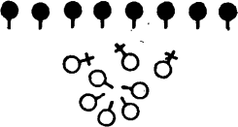
The women remain standing upright for part of the time; at intervals they bend forward and move a few steps up to the group of men and then back. In the Lahaki, which is danced very quickly and vigorously, the line of women slowly rotates round the men as it moves to and fro. The essence of the Khalaha Karma is that the line of girls should revolve quickly round the group of men. It is a double movement, for the women go in towards the men and round anti- clockwise at the same time.
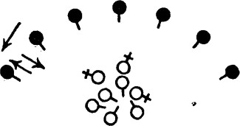

These are the very popular songs of the lowlands.
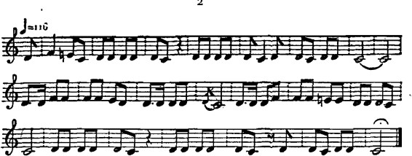

Rag: Oha hay
Tek: Pihiila kon ban khoju ga Piha basai pardesh hansiila Kon ban khoju re?
Ad: lin bangiilin beti jinaki lambi lambi kes Apan patila chhodke taje konake desh.
Rag: 0 ho a hay
Tek: Ek baje ma giidi chhutai Dui baje ma reI.
Tin baje ma saiya chhutai Phutai liilten.
Tikat kiitoga abato giidi chhutai Biliispurkha reo
Ad: Na mola khiiy jay Na mola piy jiiy
Na mola kuchhusuhiiy.

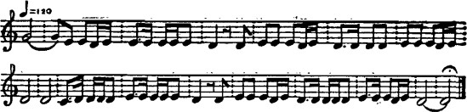

Conclusion

‘Madurkathi’ is a very high-yielding perennial sedge. It responds to irrigation particularly in the dry and warm seasons. It also responds to heavy doses of nitrogen maturing. There are no specific high-yielding varieties, package of practices, etc. for maximizing dry mat-stick yield. So there is enough scope to work. But the handloom mat weavers feel that due to various reasons they do not get job satisfaction in their present occupation. Due to modernization of mat industry, the handloom mat weavers face lot of problems like low wages, poor working conditions, inadequate non-monetary benefits, and insufficient work throughout the year. So, the Government should take necessary steps to overcome the problems of handloom mat weavers and improve the social status of the handloom mat weavers. It is expected that the above suggestion will help to resolve the problems faced by handloom mat weaving industry in Egra-I and Egra-II of Purba Medinipur, West Bengal.

A detailed survey on cultivation and marketing of this crop at different locations is needed. Farmers raise this crop as part of their traditional practice without much care. Improved agro- techniques such as selection of rhizomes (planting materials), better soil condition, transplanting, proper mid-term care, application of manures and fertilizers, water management practices including life-saving irrigation, and need-based plant protection measures will enable to increase the production of sedges more than twofold and also enhance the quality of mat- stick. The mat manufacturing industry, which is still continued in villages of few districts of West Bengal, Tamil Nadu, and Kerala, needs to be expanded to other parts of India, particularly to uplift the resource-poor rural people through income generation.

References
Amalraj VA. 1985. ‘Korai’ – A proﬁ table crop for marshy lands. Indian Farming 35(8):35–56.
CSIR. 1988. The Wealth of India – Raw Materials. A Dictionary of Indian Raw Materials
and Industrial Products. Vol. IIC. Council of Scientiﬁ c and Industrial Research, New
Delhi, India. p. 423.
Jana K and Puste AM. 2012. Effect of water management practices on dry mat-stick yield of
mat-sedges (Cyperus tegetum R.) for sustainability of resource poor farming com
munity. Green Farming 3(3):277–281.
Puste AM. 2004. Aquatic non-food commercial crops. In: Agronomic Management of Wet
land Crops. Kalyani Publishers, India. pp. 198–206.
Sarkar R and Samanta N. 1987. Cultivation of the matreed in West Bengal. Indian Farming
30 (11):16–17.
Watt G. 1889. A Dictionary of the Economic Products of India. Volume 2. Cosmo
Publications, New Delhi, India. 688 pp.

---

